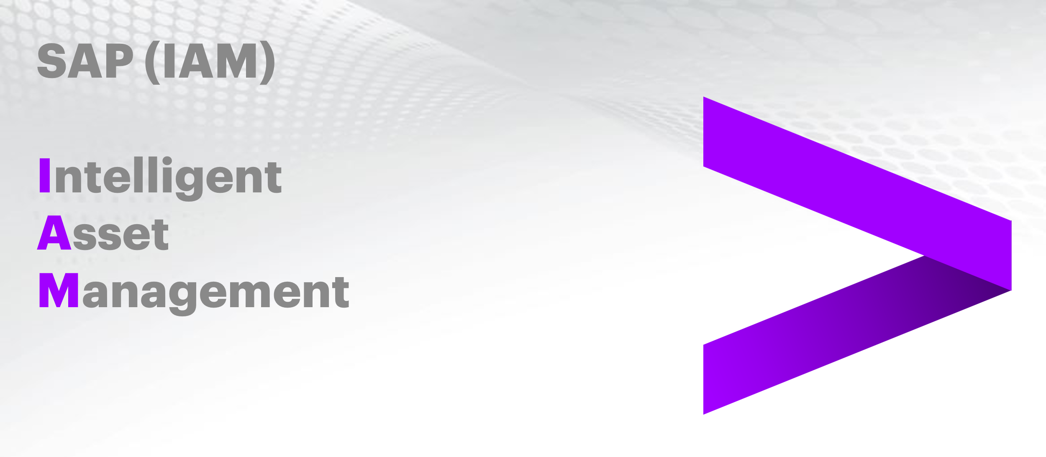

Creating Reliability Centered Maintenance Assessments

Document Control

Prepared by:
Version | Date | Name
1.0 | 01/20/2025 | MARIAM FATMA
2.0

Reviewed by:
Version | Date | Name
1.0 | 01/21/2025 | NIKHIL KOOLWAL, SRINIVAS RAO PATHI, VIJAY PATIL
2.0

Reference Documents

The following section describes relevant documentation:
Document Name | Description | Sharepoint Link
Creating Reliability Centered Maintenance Assessments | Creation and execution of a Reliability Centered Maintenance (RCM) Assessment in APM | Creating Reliability Centered Maintenance Assessments.pdf

Contents

1. Creating Reliability Centered Maintenance Assessments 4
1.1 Objective 4
1.2 Key Terms, Used in This Lesson: 4
2. Lesson Overview: Development of a Reliability-Centered Maintenance (RCM) Assessment 6
2.1 Create the RCM Assessment 7
2.2 Assign the Failure Data Profile Components and Create a Recommendation 11
3. Conclusion 29
3.1 Objective: 29
3.2 Overview: 29
3.3 Outcome 31

1. Creating Reliability Centered Maintenance Assessments

  - Objective

After completing this lesson, you will be able to develop a Reliability-Centered Maintenance (RCM) Assessment, including the identification of critical maintenance tasks and optimization of maintenance strategies
1.2 Key Terms, Used in This Lesson:

- RCM Assessment: A systematic process to determine the maintenance requirements of an asset to ensure its reliability.
- Function: The intended purpose or role of an asset within its operational
context.
- Functional Failure: A state in which an asset fails to perform its intended
function.
4. Failure Modes: Reasons or methods in which an asset can fail.
5. Failure Mechanisms: The processes or events that lead to the occurrence
of a failure mode.
6. Causes: The specific reasons why a particular failure mode occurs.
7. Failure Effects: The consequences that result from a failure occurring.
8. Consequence Evaluation: A part of the RCM assessment that determines
the impact of failure modes and guides the decision-making process.
9. Failure Data Profile: A compilation of failure-related information that is
attached to a technical object.
10. Decision Diagram: A tool used during Consequence Evaluation to guide
the user through a series of questions that determine the appropriate
course of action.
11. Business Scenario: Development of a Reliability-Centered Maintenance (RCM) Assessment.

2. Lesson Overview: Development of a Reliability-Centered Maintenance (RCM) Assessment

Reliability Centered Maintenance Assessments, or RCM assessments for short, are used to understand what an asset does during typical operation, what happens when the asset ceases to operate, and the details surrounding the asset failure. They are similar to Strategy Assessments but are on a more specific technical object level rather than the broader asset class level. Like Strategy Assessments, the same catalog components found in the Failure Data Profiles are used here, barring the maintainable items. There are also two new catalogs within RCM Assessments that are not present within Strategy Assessments, those being Functions and Functional Failures.
Here are all the catalogs used for an RCM Assessment:
• Function - What an asset's main purpose is (pipe transfers gas from point A to B).
• Functional Failure - What is the asset doing now after failure (gas does not transfer to point B).
• Failure Modes - Why the item or asset failed (corrosion of pipe).
• Failure Mechanisms - Process leading to asset failure (prolonged exposure to water).
• Causes - What made the Failure Mode occur (humid work environment).
• Failure Effects - Result of Failure Mode occurring (leakage of pipe).
Inside of a Failure Mode, we can fill out a Consequence Evaluation. This provide us with a questionnaire where depending on the answers provided, it will provide a general recommendation as to what the best response may be to handle asset failure.
A recommendation can also be added into the assessment. This recommendation will inform the user in the case of this particular asset failure occurring for the specified asset class, this is the best way to handle this situation.
2.1 Create the RCM Assessment

On the main page of APM, choose the RCM Assessments tile. The tile is in the Assessment Management tab and should be the fourth tile in the row. If not present, you should also be able to locate the tile by going to the search bar at the top, typing RCM Assessments in the search field, and then hitting the search button.
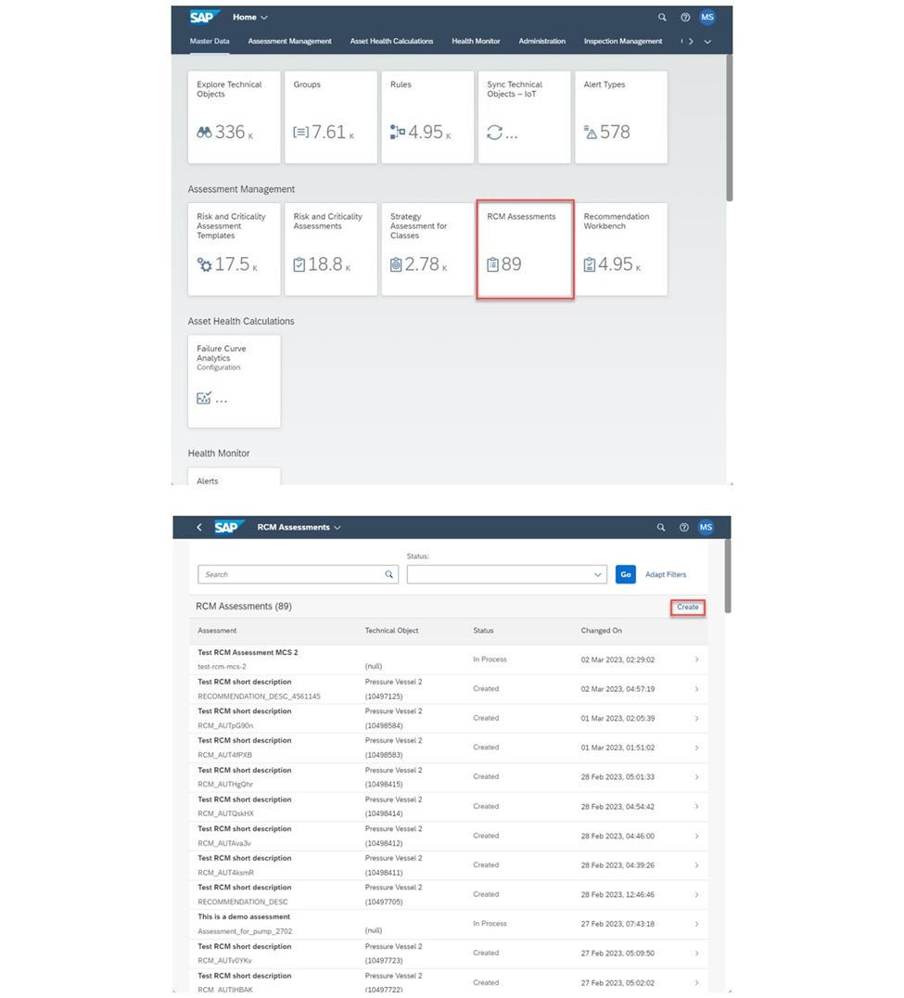
In the RCM Assessments page, all the previously made RCM assessments will appear with options to search and filter for particular Assessments. To create a new Assessment, choose the Create button to the right of the page underneath the Go and Adapt Filters buttons at the top.

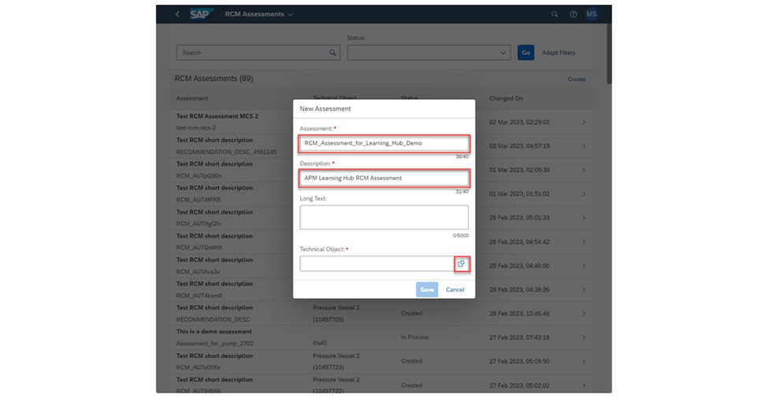

In the New Assessment dialog box, Enter in the Assessment and Description fields. The Long Text field is optional and can be used to provide additional information pertaining to the RCM Assessment. Once finished, choose the box on the right of the Technical Object field to select the Technical Object you will be assessing.
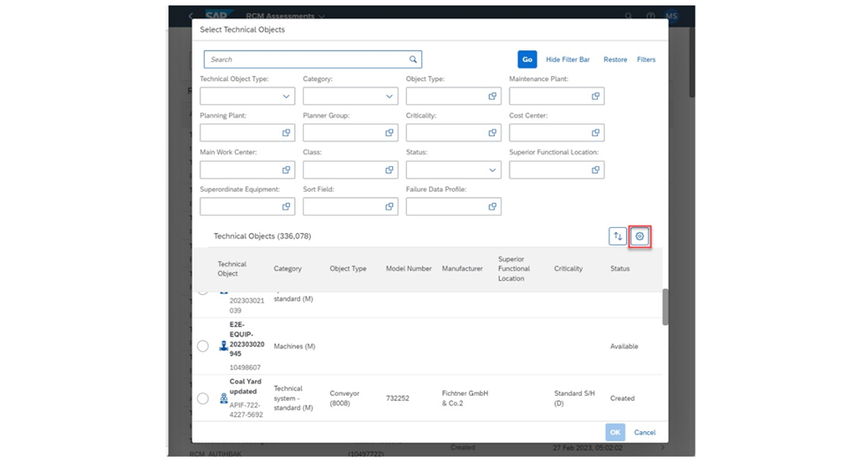

On the Select Technical Objects page, choose a Technical Object to assess. Note that the Technical Object must have a Failure Data Profile attached to it. If there is no Failure Data Profile attached to the Technical Object, you will not be permitted to go through with creating the Assessment and must pick another. To ensure you are performing an Assessment on a Technical Object that does have a Failure Data Profile, choose the Settings button on the right of the pop up. It will be denoted with a gear icon and is underneath all the filters you can configure.
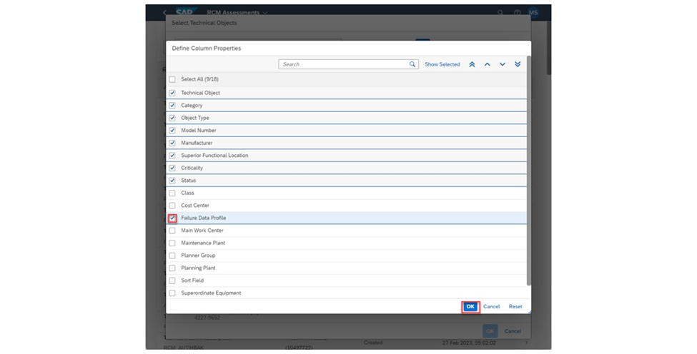
You can add or remove other displayed columns in the Select Technical Object list here. Check Failure Data Profile to add it into the list and choose the OK button on the bottom right to confirm that this column will display.
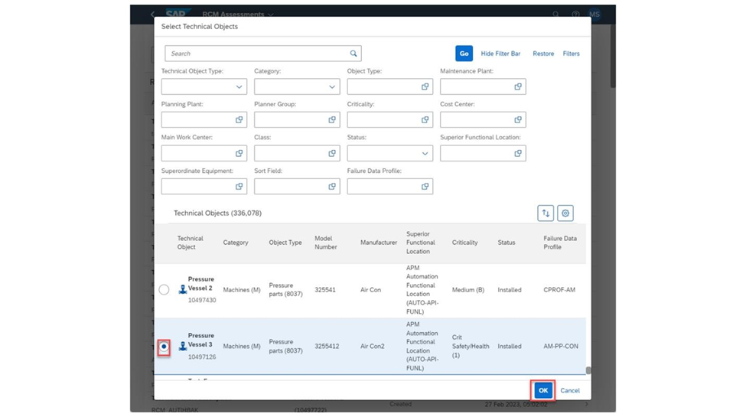

Now with the extra column added in, you should be able to choose a Technical Object with a Failure Data Profile. Select the Technical Object you wish to use and then choose the OK button to use this Technical Object for the assessment.

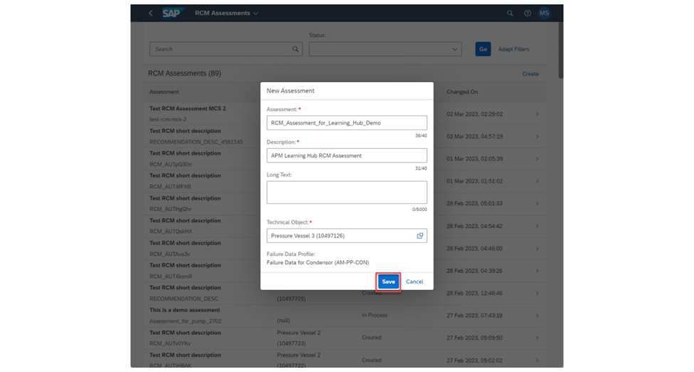

All the required fields for creating the RCM Assessment have now been filled out. The Failure Data Profile that is assigned to the Technical Object is also being displayed underneath it as well. Choose the Save button on the bottom of the pop up to create the Assessment. Note that if the Technical Object already has an RCM Assessment underway on it, it cannot be used for a new RCM Assessment.

2.2 Assign the Failure Data Profile Components and Create a Recommendation

With the assessment created, we will need to assign the Functions, Functional Failures, Failure Modes, Failure Mechanisms, Causes, and Failure Effects. Note that only the Functions, Functional Failures, and Failure Modes are required for the Assessment. To assign the Functions to the RCM Assessment, choose the Assign Functions button in the Assessment tab in the middle of the page.

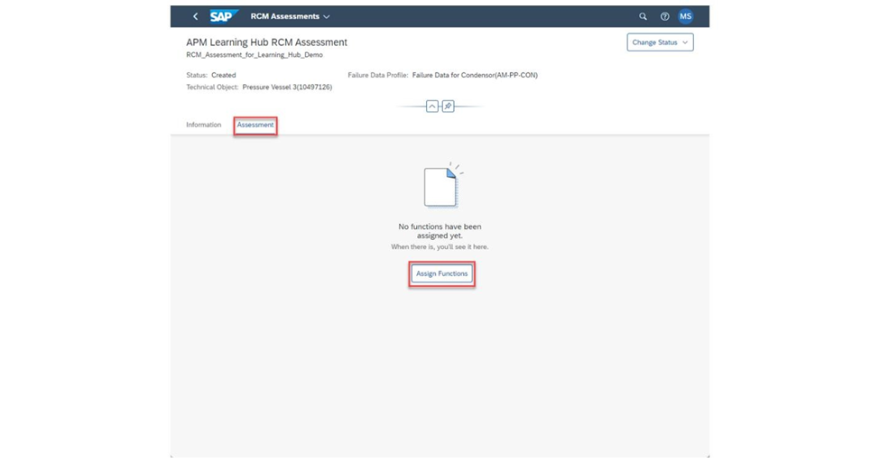
In the list of Functions, check one or more Functions to the Assessment. Use the search bar to find specific Functions in the list. Choose the Additional Options button on the top right of the page to create a new Function if necessary. Check one of the Codes in the Codes Groups in the list to add a new Code to that Code Group.
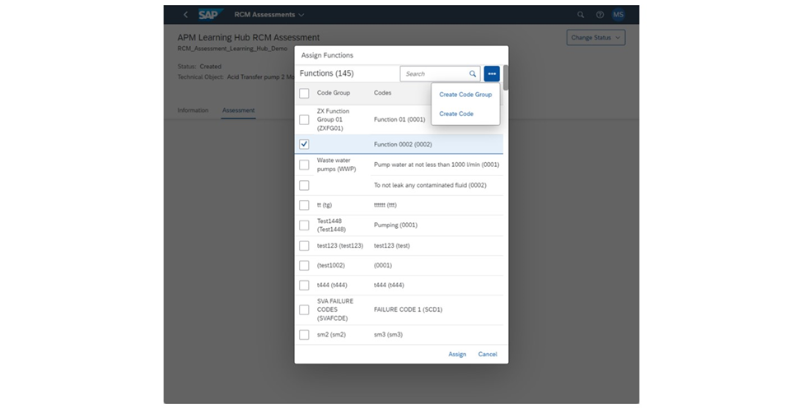
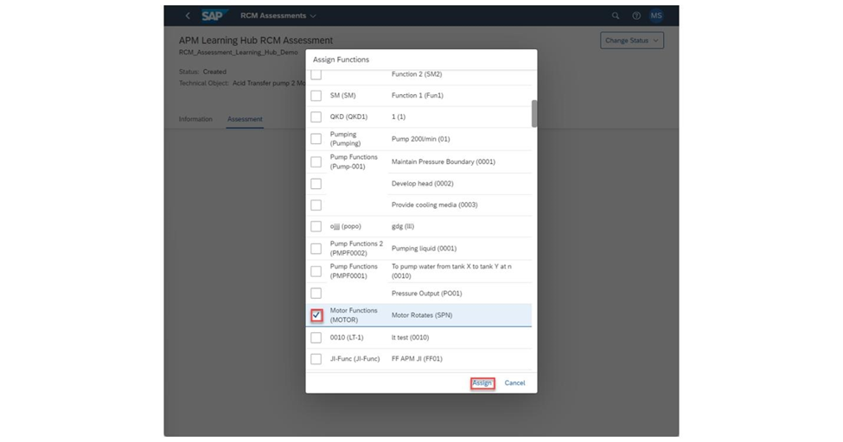
If not adding in any new functions, check at least one function from the list and choose the Assign button at the bottom of the pop up to assign the selected Functions to the Assessment.
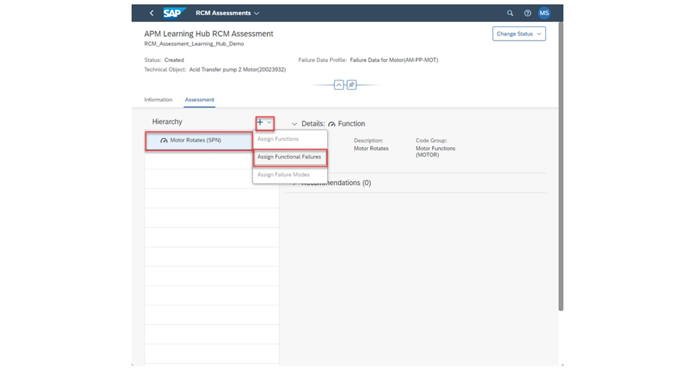

Now that one or more Functions have been assigned, now we can either assign more Functions or assign one or more Functional Failures underneath the Function. Typically, though, it is only one Functional Failure underneath a Function. Choose the Failure you wish to add a Functional Failure to and then choose the + button, followed by the Assign Functional Failures button.
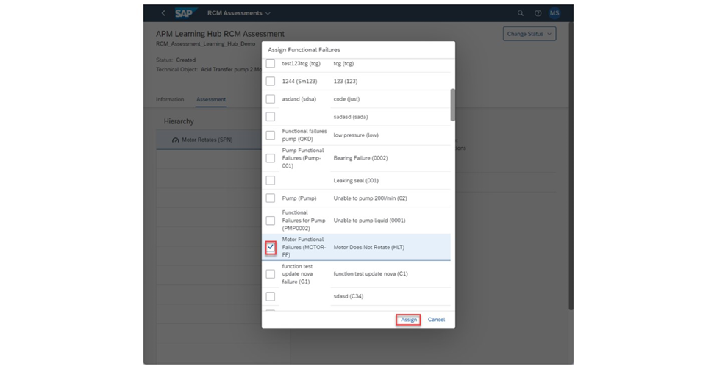
Same the Assign Failures list, you can check a Functional Failure to Assign underneath your selected Function, create a new Code Group and Code with it, or create a new code in an existing Code Group. Check the Functional Failure(s) you wish to use and then choose the Assign button.
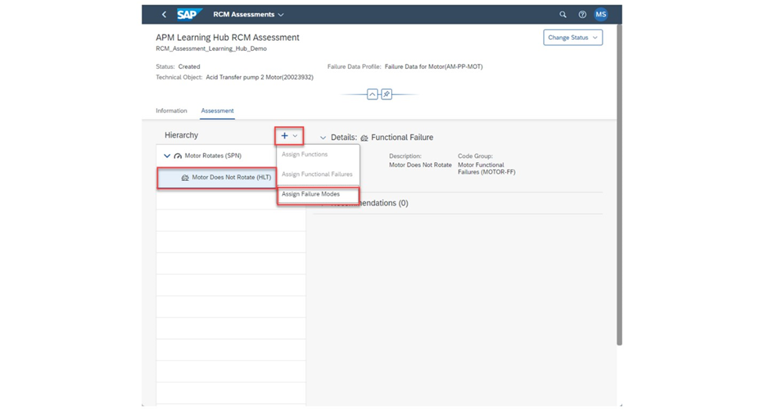
Repeat the same process again for the one or more Failure Modes you wish to assign to the Functional Failure. Make sure you choose the Functional Failure to have the option to choose the Failure Mode button.
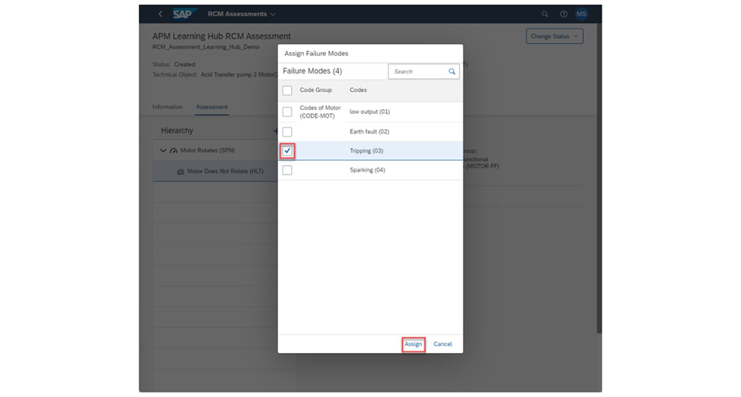
The Failure Modes here will come from the Failure Data Profile that is assigned to the Technical Object the Assessment is being done on. Check the Failure Modes you will use and choose the Assign button.
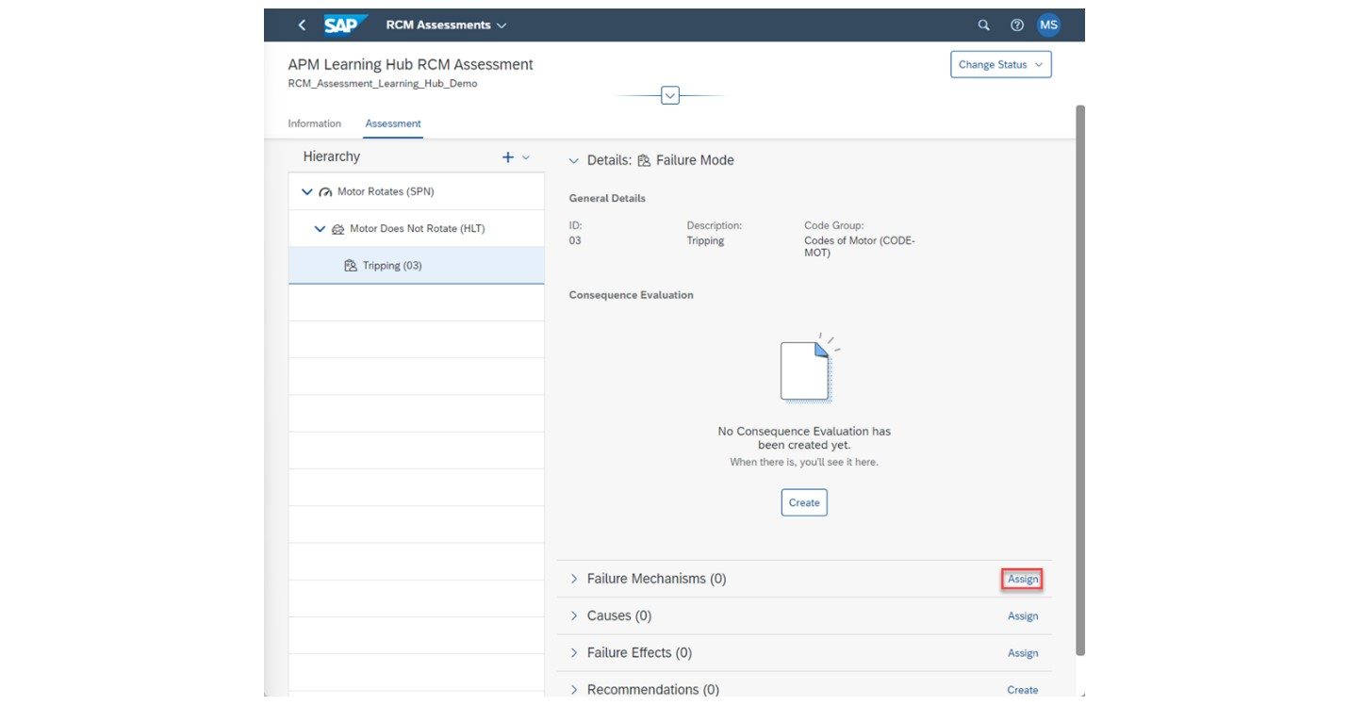
Before creating the Consequence Evaluation, we can assign the rest of the Failure Catalogs and create a Recommendation to use, although either one can be done first. Note that for the Recommendation, we can use the other Failure Catalogs within it. It is best to wait for the other Catalogs to be assigned before creating the Recommendation. With that said, choose the Assign button next to the Failure Mechanisms Text inside of the desired Failure Mode to assign it in here.
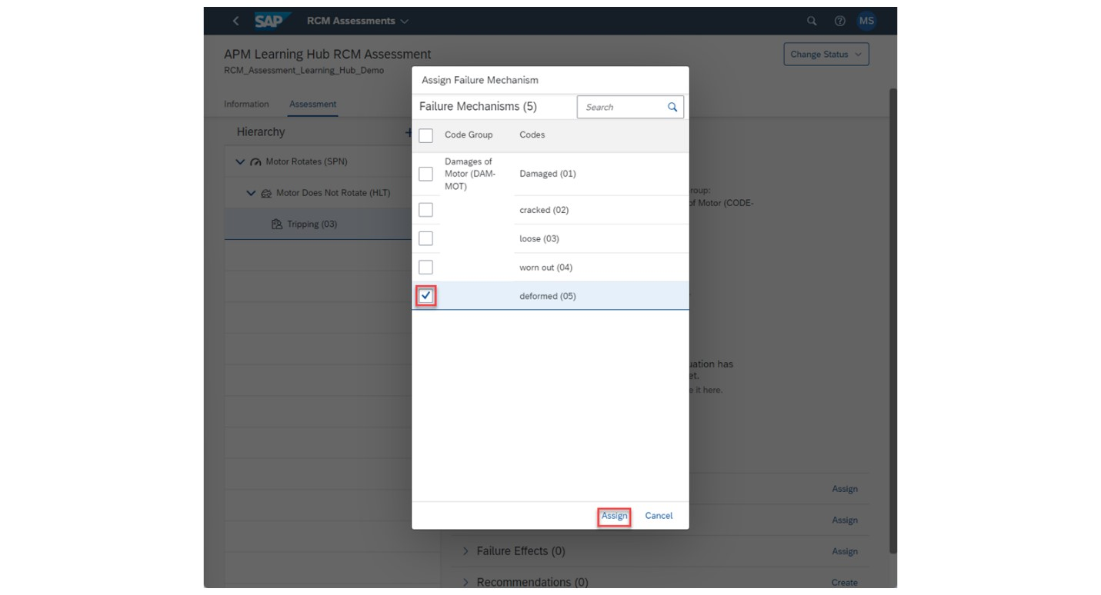
Check the Failure Mechanisms you wish to use and choose the Assign button.
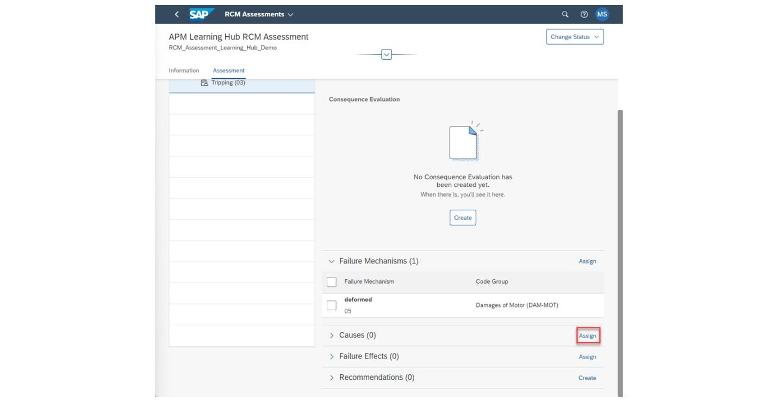
Repeat this process again for the Causes.

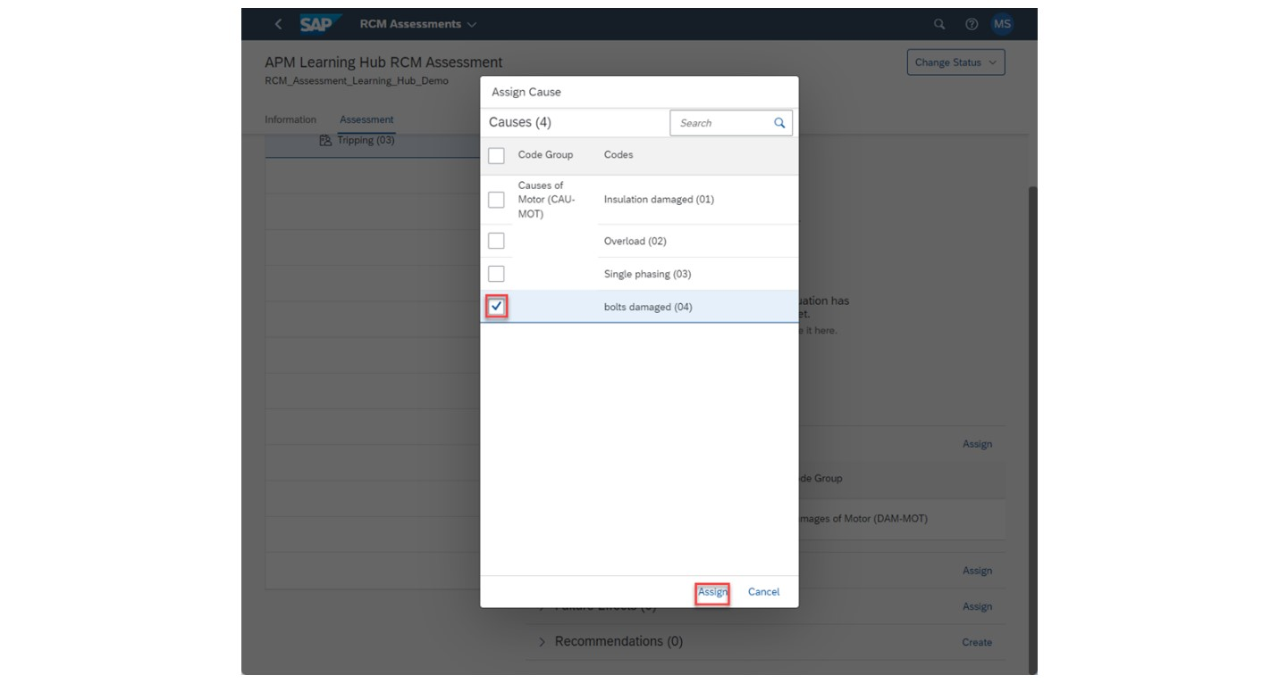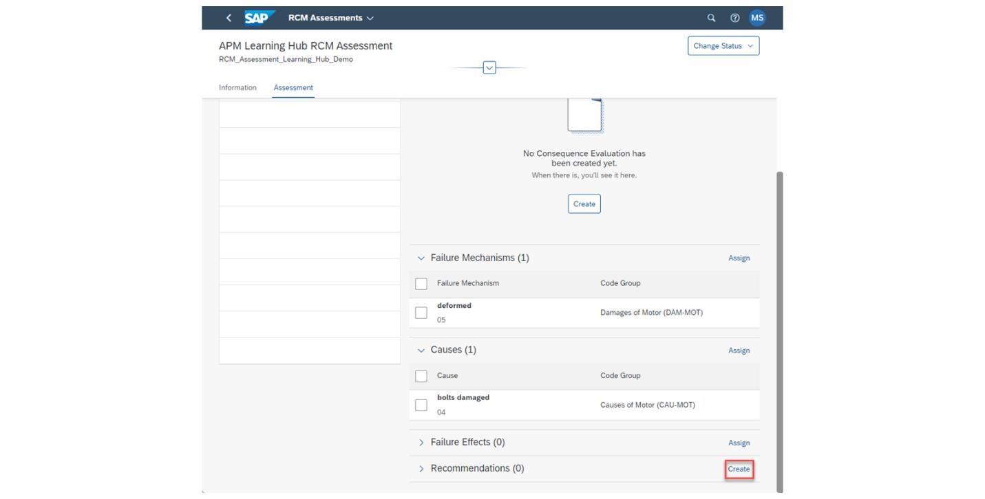

The same process can be repeated for the Failure Effects as well. The Failure Data Profile that I am using does not have any Failure Effects in it so I will leave it blank. Feel free to add one in though if you would like. With this done, we will add in a Recommendation to the Assessment. Choose the Create button to the right of the Recommendations text in the Failure Mode to generate a new Recommendation.

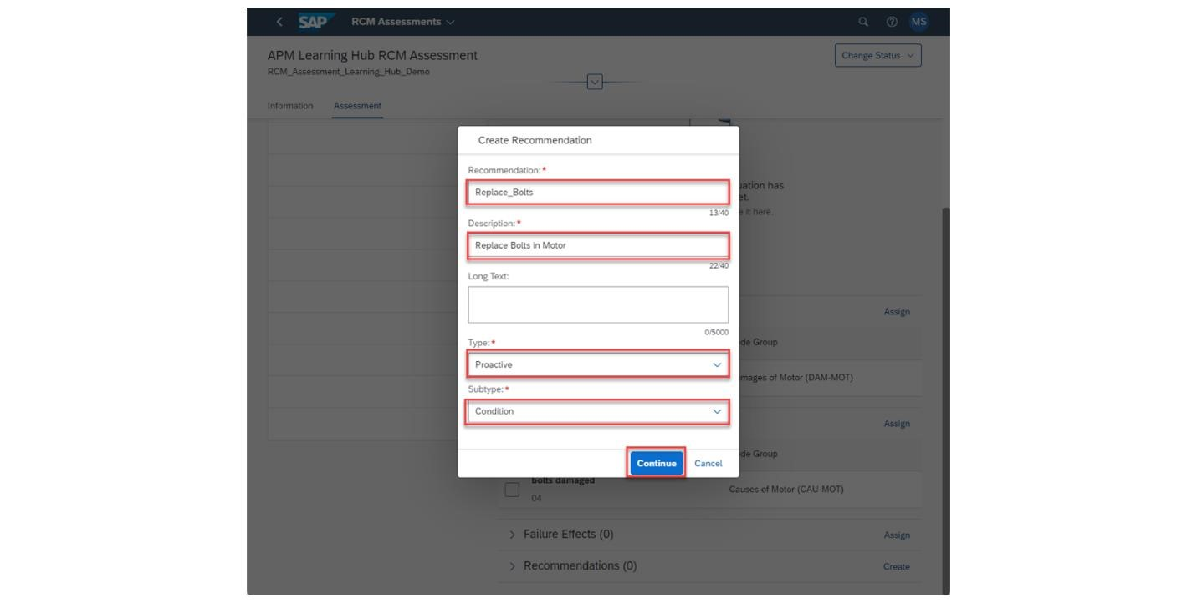
Fill out the Recommendation, Description, and Type fields for your Recommendation. If a Proactive Type is chosen as the Recommendation type, an additional Subtype needs to be selected as well. With all necessary fields filled in, choose the Continue button at the bottom of the pop up.

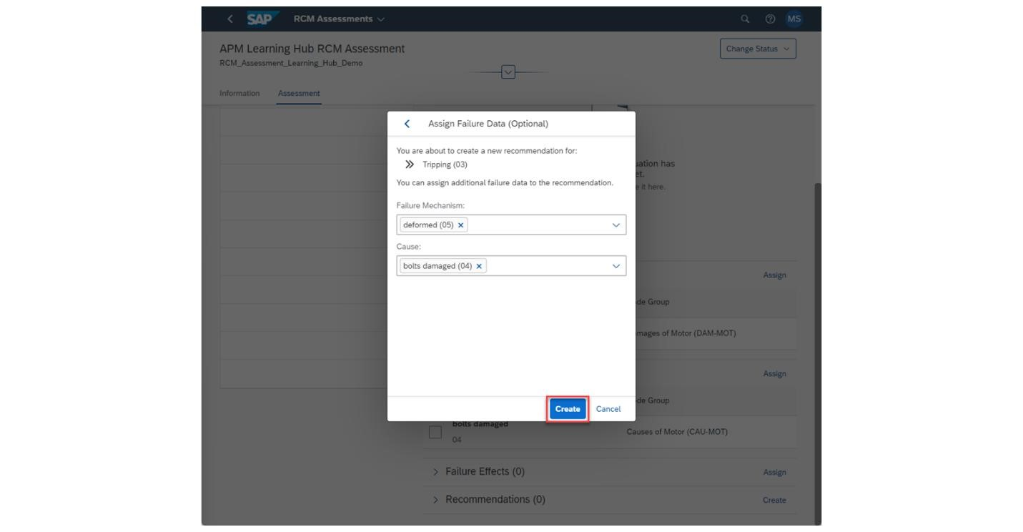

All the additional Failure Catalogs that were added underneath the Failure Mode that the Recommendation is being made in will appear here in drop downs. You can select one or more of the Failure Catalogs from the drop downs to assign to the Recommendation.
If a Failure Mechanism, Cause, or Failure Effect was not assigned to the Failure Mode, it will not appear here on the pop up. Assign the Failure Data here and choose the Create button once finished to create the Recommendation. Change Assessment Status and Perform Consequence Evaluation.

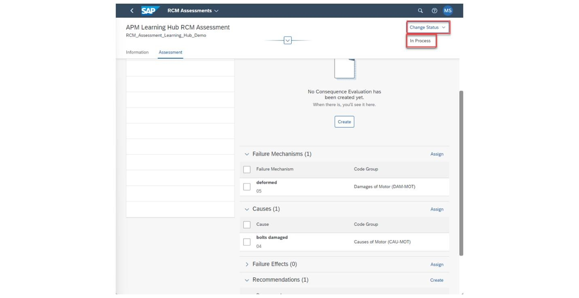
While working on an Assessment, it is generally considered good practice to change the status of it to In Process to denote that the Assessment is actively being changed and is not empty. To change the status of the Assessment, choose the Change Status button at the top right of the page and then choose the In Process sub button underneath it.
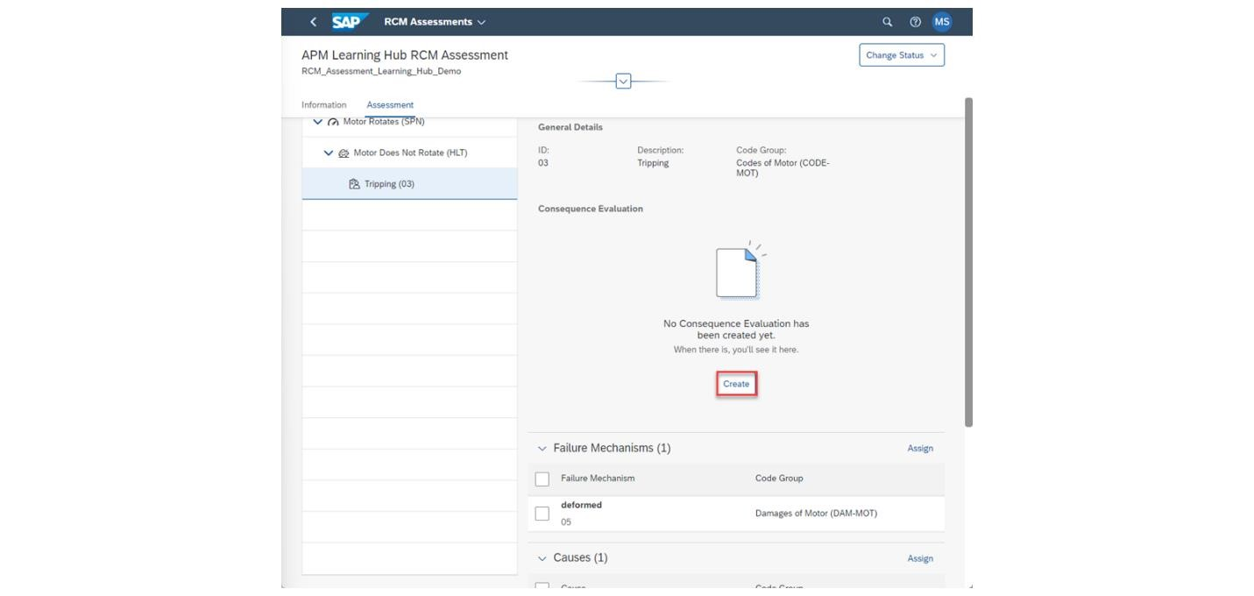

As of writing this guide, an RCM Assessment cannot be set to the Released status. This will remain under the In Process Status for now.
To create a Consequence Evaluation, choose the Failure Mode in the hierarchy that you wish to perform the evaluation on. Then under the Consequence Evaluation section, hit the Create button in the center to create the evaluation.
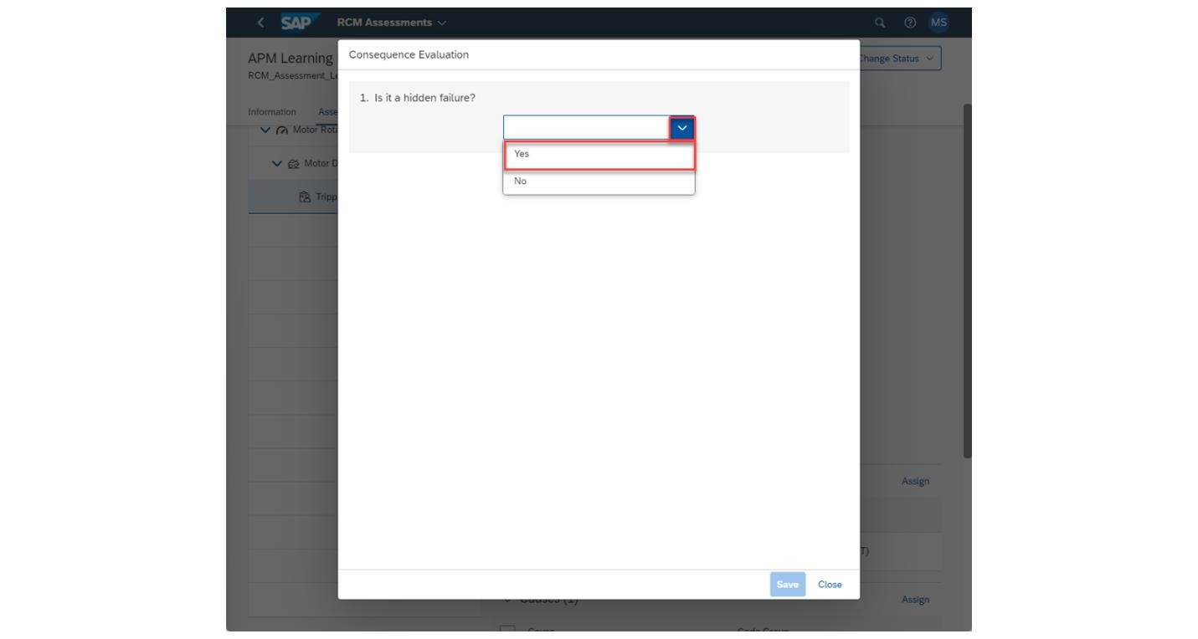
In the Consequence Evaluation pop up, you will be prompted with the first question in the Consequence Evaluation. Depending on how the question is answered, the following question may or may not result in a different question being asked.
They way you answer questions will lead you down different paths in the Decision Diagram. Select Yes or No as your answer for the first question in the Consequence Evaluation.

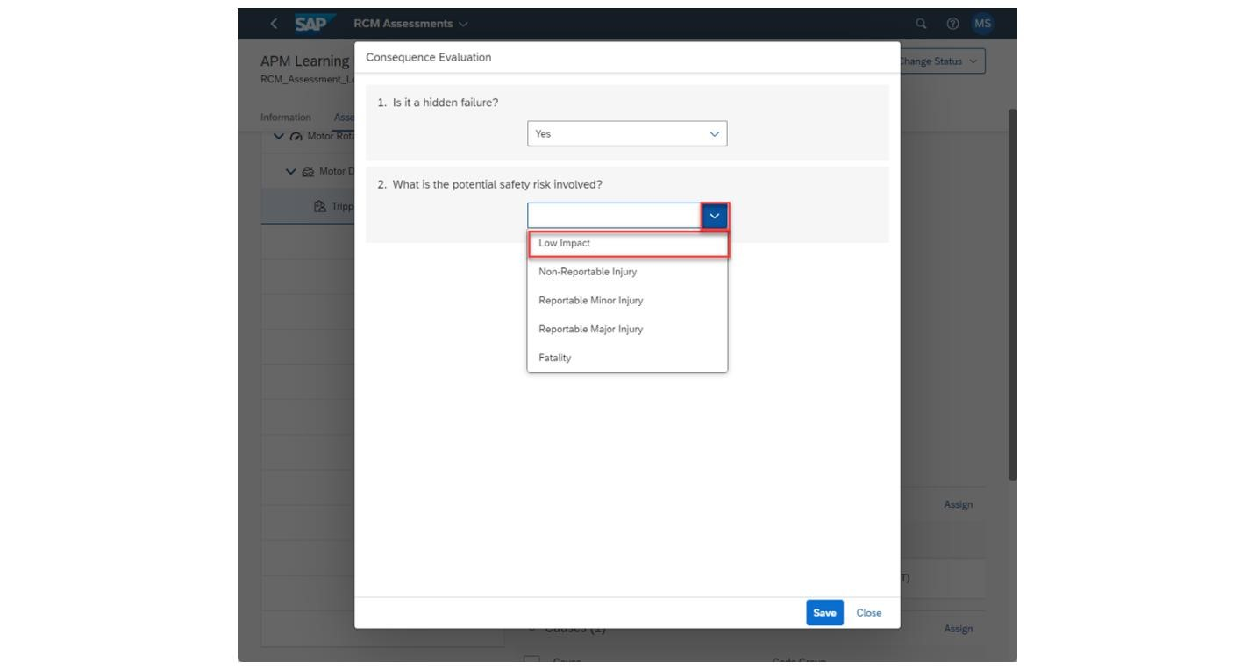
The next question here is the same regardless of how you answer the first. Provide an answer from the dropdown of the second question. Depending on how you answer, you will be brought down a different path of the Decision Diagram.

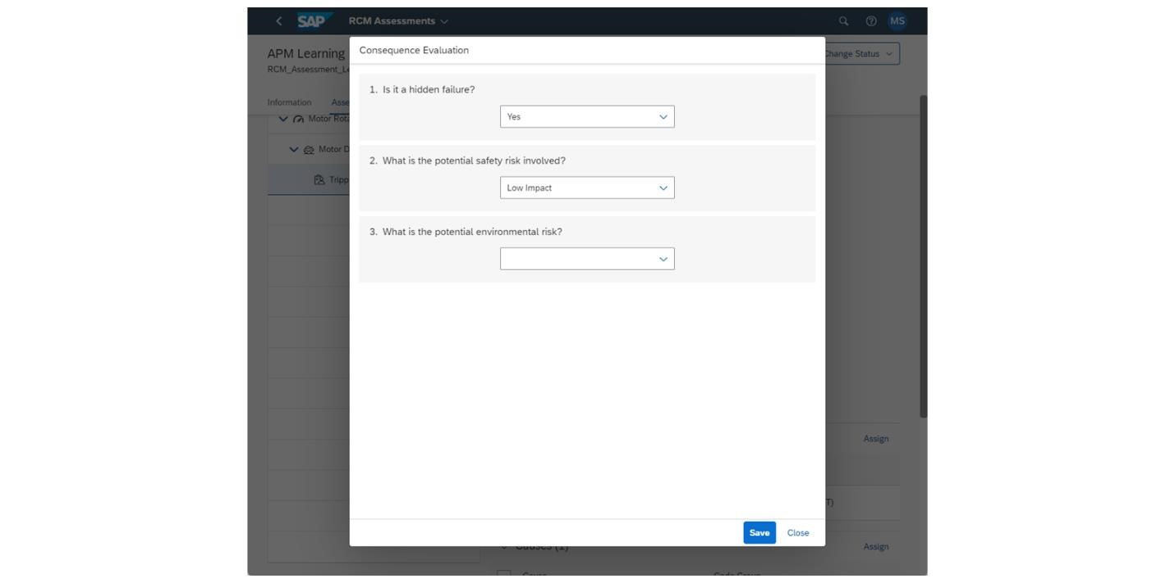
Answering the second question as Low Impact led me to my third question asking about environmental risk. I can continue with the Consequence Evaluation from here if I want to and answer the new question that came up.

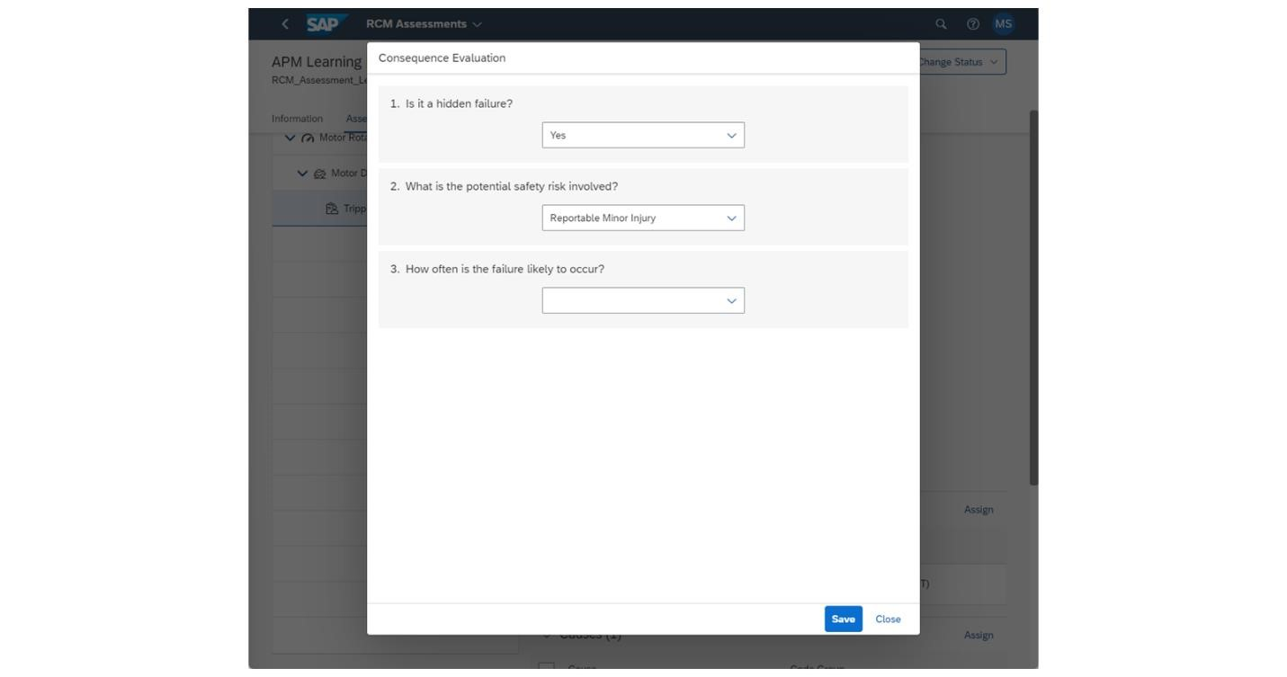

If I change the second question's answer to something else, I may go down a new path in the Decision Diagram. This is the new question I get when I change the answer in my second question from Low Impact to Reportable Minor Injury.
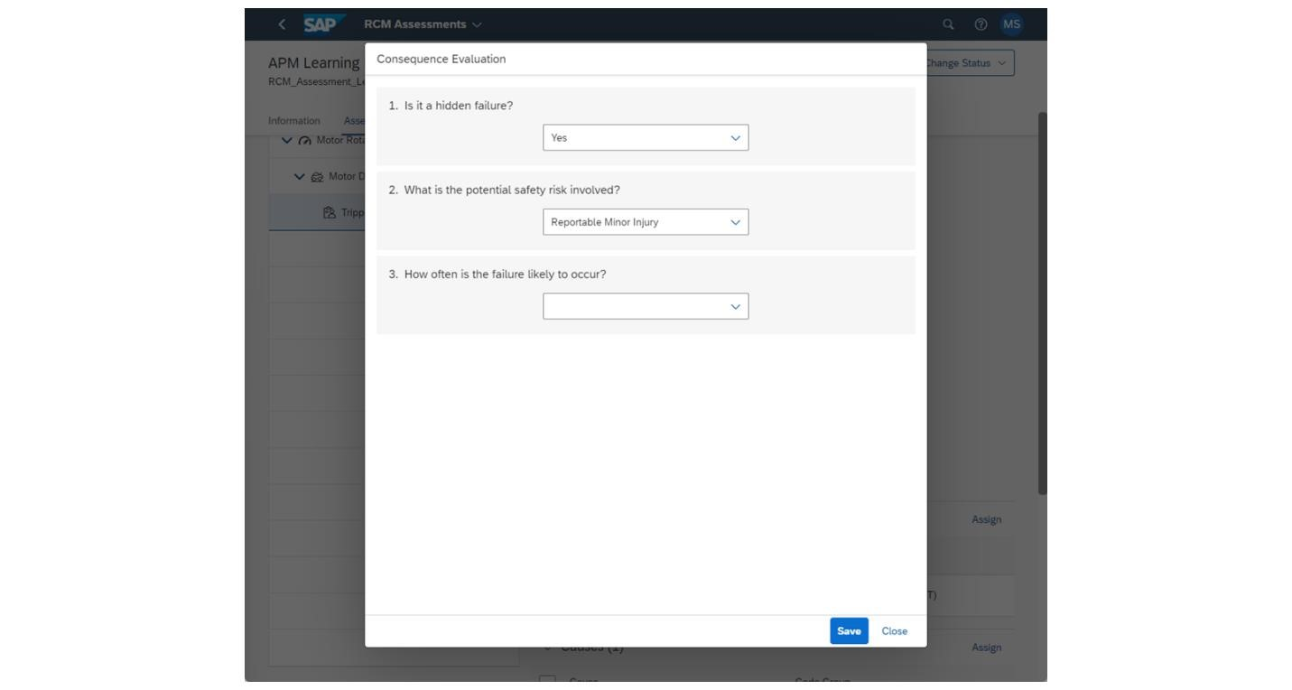
Instead of asking about environmental risk, it is now asking about how often this failure may occur. Answering questions differently will lead to different questions being asked later down the evaluation.

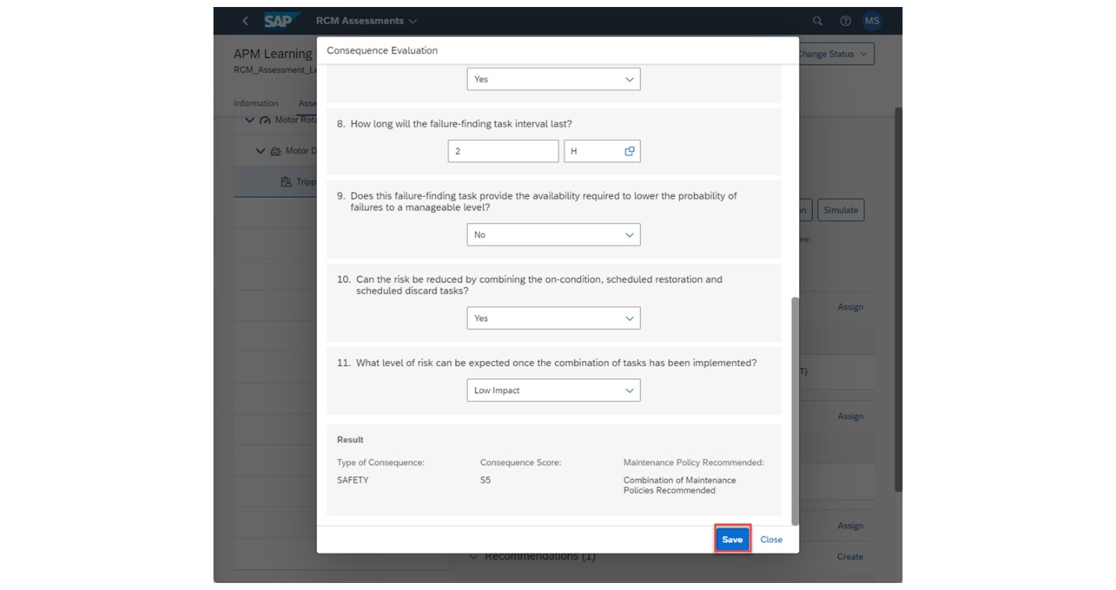
Keep answering the Consequence Evaluation until no further questions are asked. At the end of the evaluation, a Result section will appear. This will show the consequence type, score, and general recommendation on how best to approach the failure of the asset. Choose the Save button on the bottom to keep this evaluation to the Failure Mode.

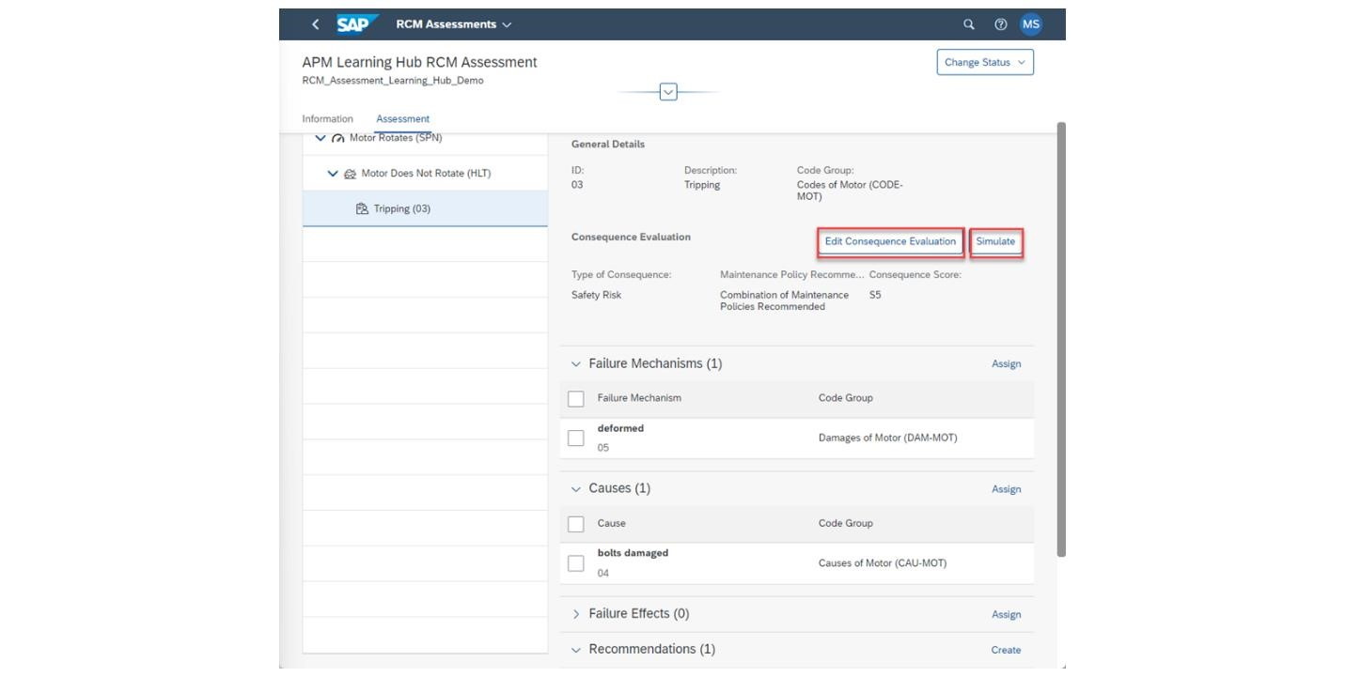
With the Consequence Evaluation completed, there are two new buttons that appear. There is the Edit Consequence Evaluation button which will let you perform it again.
You can also choose the Simulate button to have a graphical view of the Consequence Evaluation performed as well as the answers that are provided here.

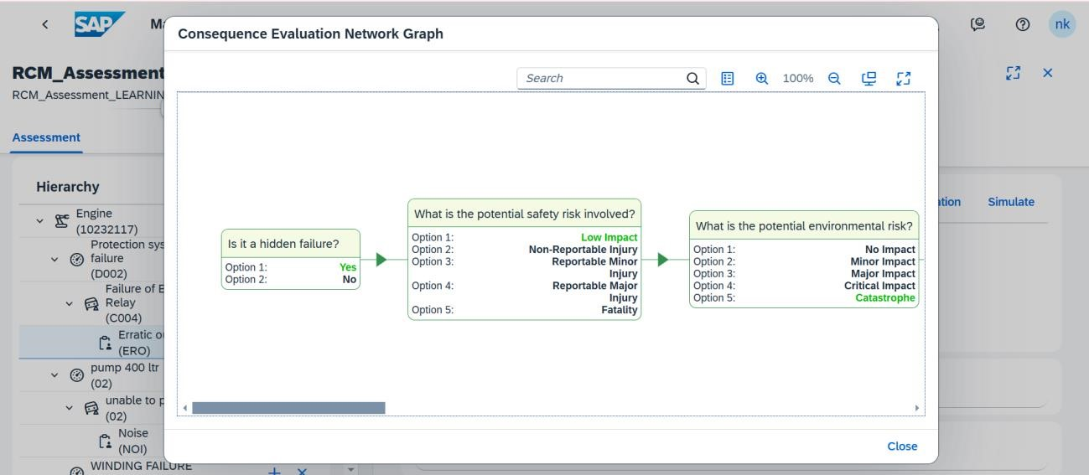

3. Conclusion

3.1 Objective:

To understand the creation and execution of a Reliability Centered Maintenance (RCM) Assessment in APM, which offers a detailed examination of asset operation, failure modes, and consequences at the level of specific technical objects.

3.2 Overview:

RCM Assessments delve into asset functionality, failure behaviors, and consequences.
These assessments incorporate several catalogs of data, including Functions, Functional Failures, and Failure Modes, with an additional focus on Consequence Evaluation to guide response strategies.

Steps to Create an RCM Assessment:
- Initiating the Assessment:

- Select "RCM Assessments" from the Assessment Management tab.
- Use the Create button to initiate a new RCM Assessment.

- Filling Assessment Details:

- Enter Assessment name and description.
- Choose the Technical Object with an attached Failure Data Profile.

- Assigning Failure Data Profile Components:

- Assign Functions, Functional Failures, and Failure Modes from the Failure Data Profile to the Assessment.
b. Assign Failure Mechanisms, Causes, and optionally, Failure Effects.

- Creating Recommendations:

a. Formulate Recommendations for asset failures, considering the previously assigned catalogs.
b. Define the type and details of each Recommendation and link it to the appropriate Failure Modes.

Consequence Evaluation:

- Starting the Evaluation:

- Change the Assessment's status to "In Process" to indicate active modification.
- Create a Consequence Evaluation for a selected Failure Mode.

- Answering Evaluation Questions: Respond to questions sequentially; each answer may lead down a unique path in the Decision Diagram.

- Reviewing Consequence Results: Upon completion, review the consequence type, score, and suggested approach for handling the asset's failure.

3.3 Outcome

Completing an RCM Assessment equips users with in-depth insights into asset performance and failure consequences. Recommendations generated from the assessment provide strategic actions to manage and mitigate risks associated with asset failures.

